ACAMIS TA Conference Visible Thinking Routine

Instructions:
As you listen to each session, fill in the chart below. One row for each session.

 | How do the ideas and information shared connect to what you already know? | 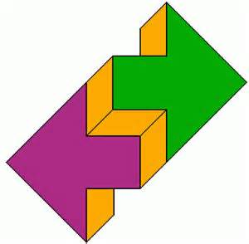  What new ideas did you learn that extended or pushed your thinking in new directions? | What is still challenging or confusing for you to get your mind around? What questions, do you have now?
 | CONNECT | EXTEND | CHALLENGE
Session Title:

Presenter(s):
Session Title:

Presenter(s):
Session Title:

Presenter(s):
 | How do the ideas and information shared connect to what you already know? | What new ideas did you learn that extended or pushed your thinking in new directions? | What is still challenging or confusing for you to get your mind around? What questions, do you have now?
 | CONNECT | EXTEND | CHALLENGE
Session Title:

Presenter(s):
Session Title:

Presenter(s):
Session Title:

Presenter(s):

